LAB 2 REPORT
KRISHNA CHAITANYA NALLURI
16157744

Data collection from BLE Sensor Tag and Android Mobile Device:
I have used the BLE sensor tag and my android device to collect the data. Text file is generated in my android device. I downloaded and imported the app1-app3 from the material given, and using this i have collected the data.
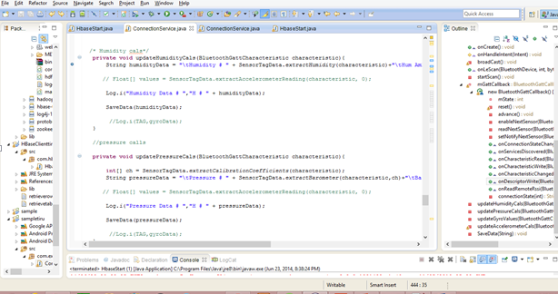

TASK 2: HBASE
Created a table in the HBASE of name SensorTagTableknhy3 and i have inserted the data into that table.

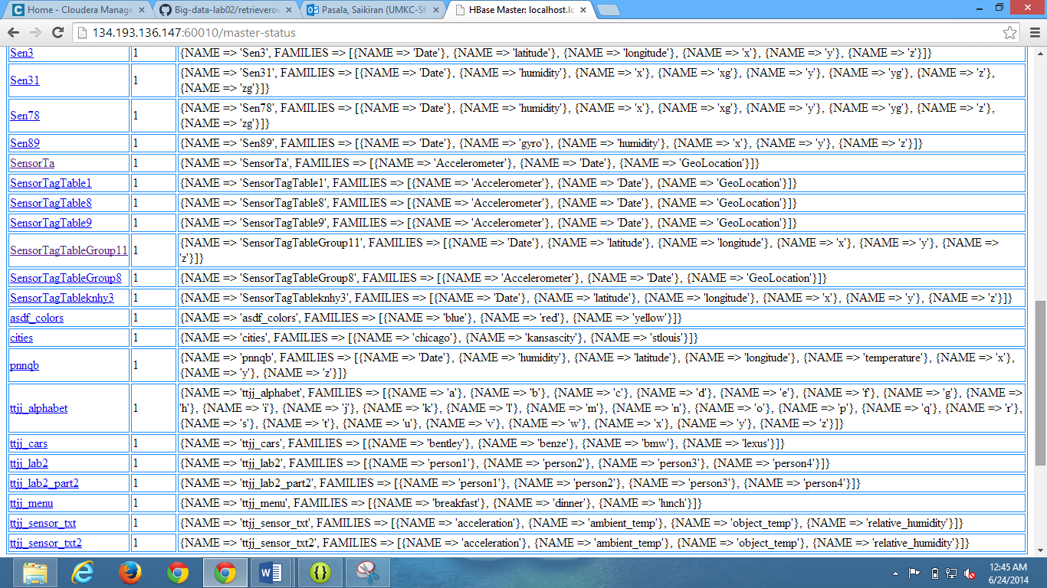

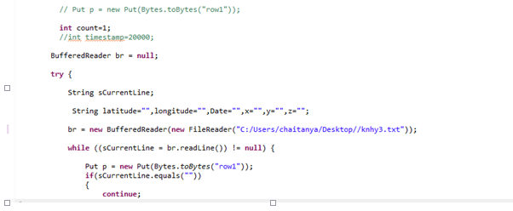
I have inserted the data which is collected from the HBASE.

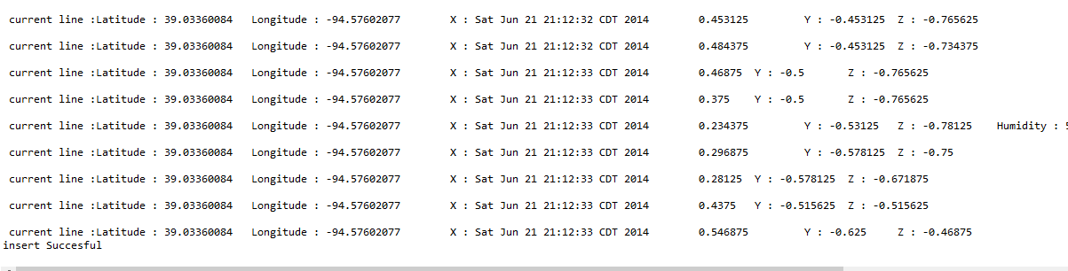
After the insertion, i have retrieved the data.

